Tutorial 8: LAN Security Concepts

- How does AAA security model works in the context of computer networking? Explain.

- AAA stands for Authentication, Authorization and Accounting, and provides the primary framework to set up access control on a network device.
- AAA is a way to control who is permitted to access a network (authenticate), what they can do while they are there (authorize) and to audit what actions they performed while accessing the network (accounting).

- Explain TWO (2) common methods of implementing AAA authentication.

- Local AAA Authentication
  - Method stores usernames and passwords locally in a network device.
  - users authenticate against the local database.
  - Local AAA is ideal for small networks.
- Server-Based AAA Authentication
  - With the server-based method, the router accesses a central AAA server.
  - The AAA server contains the usernames and password for all users.
  - The router uses either the Remote Authentication Dial-in User Service (RADIUS) or Terminal Access Controller Access Control System (TACACS+) protocols to communicate with the AAA server.
  - When there are multiple routers and switches, server-based AAA is more appropriate.

- Give example for the following of Switch Attack Categories.

Category | Examples
MAC Table Attacks | Includes MAC address flooding attacks (spam MAC table with different frames with different source and MAC addresses)  When MAC table is full, all of the remaining frame received will directly forwarded to all available ports.
VLAN Attacks | Includes VLAN hopping and VLAN double-tagging attacks. It also includes attacks between devices on a common VLAN.
DHCP Attacks | Includes DHCP starvation and DHCP spoofing attacks.
ARP Attacks | Includes ARP spoofing and ARP poisoning attacks.
Address Spoofing Attacks | Includes MAC address and IP address spoofing attacks.
STP Attacks | Includes Spanning Tree Protocol manipulation attacks.

- Describe the MAC Address Table Flooding attack.

- All MAC tables have a fixed size and consequently, a switch can run out of resources in which to store MAC addresses.
- MAC address flooding attacks take advantage of this limitation by bombarding the switch with fake source MAC addresses until the switch MAC address table is full.
- The switch will treat the frame as an unknown unicast and begins to flood all incoming traffic out all ports on the same VLAN without referencing the MAC table.
- It allows a threat actor to capture all of the frames sent from one host to another on the locatl LAN or local VLAN.

- With reference to the following diagram (Figure 8.1), explain VLAN Hopping Attacks.
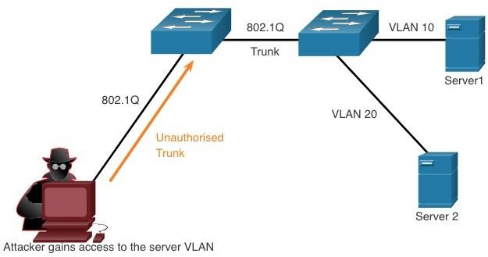

Figure 8.1 VLAN Hopping Attacks

- VLAN hopping attack enables traffic from one VLAN to be seen by another VLAN without the aid of a router.
- The threat actor configures a host to act like a switch to take advantage of the automatic trunking port feature enabled by default on most switch ports.
- The threat actor configures the host to spoof 802.1Q signaling and Cisco-proprietary Dynamic Trunking Protocol (DTP) signaling to trunk with the connecting switch.
- If successful, the switch establishes a trunk link with the host. Now the threat actor can access all the VLANs on the switch.
- The threat actor can send and receive traffic on any VLAN, effectively hopping between VLANs.

- There are two types of DHCP attack which are DHCP starvation and DHCP spoofing. Explain DHCP starvation and DHCP spoofing attack.

- Address Resolution Protocol (ARP) attacks, often referred to as ARP spoofing or ARP poisoning, are a type of cyber-attack carried out over a local area network (LAN). Describe TWO (2) common methods that an ARP attack can be conducted by a threat actor.

- What are the mitigation methods for the following LAN attacks?

LAN attacks | Mitigation methods
MAC address flooding attacks
VLAN hopping and VLAN double-
tagging attacks
DHCP starvation and DHCP spoofing attacks
ARP spoofing and ARP poisoning attacks
MAC address and IP address spoofing attacks.
Spanning Tree Protocol manipulation attacks

